Refer to https://medium.com/@christyjacob4/using-vscode-remotely-on-an-ec2-instance-7822c4032cff

At a minimum, install the Remote - SSH extension from Microsoft. The extension relies on having an OpenSSH client installed.

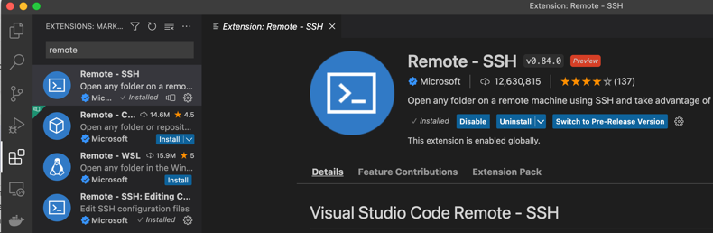

There are two additional I find helpful, also from Microsoft. Remote - SSH: Editing Configuration Files provide syntax highlighting when editing the SSH Configuration files. Remote Explorer adds another app to the VS Code side bar with all the configured remote hosts listed for easy selection.

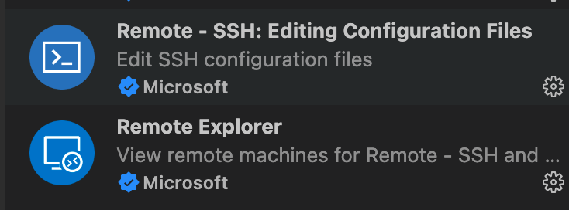

Click the green status bar item '><' in the lower left of the VSCode screen open SSH Configuration file.
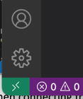
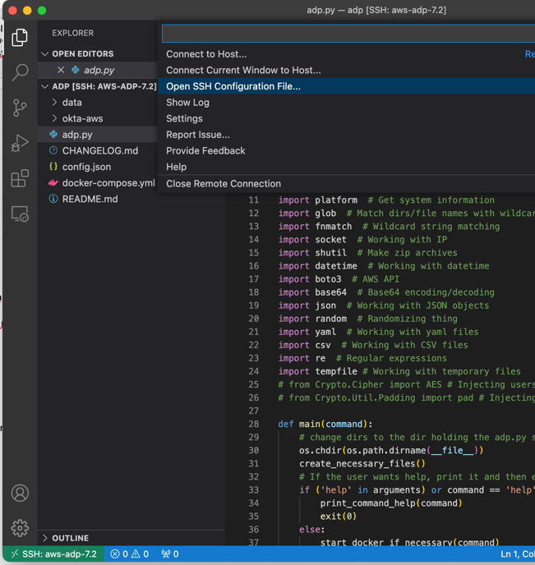

Select your personal file under your login directory. On the Mac it will be in /Users/<user-name>/.ssh/config - also known as ~/.ssh/config. The tilde (~) is *nix shorthand for your home directory.

Give the 'Host' portion an alias that you'll see when connecting from VS Code or from a command prompt. Remember the VS Code extension is sitting on top of the standard OpenSSH application and configuration.

Each Host stanza looks like:
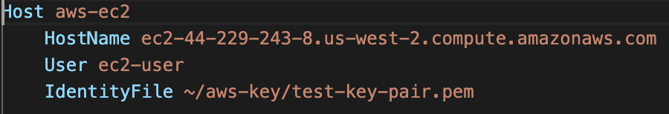
Once complete, save the file.
Since this is built on the standard ssh package, having the above stanza in the config file means from a command line,
ssh aws-ec2
is functionally equivalent to
ssh -i ~/aws-key/test-key-pair.pem \
ec2-user@ec2-44-229-243-8.us-west-2.compute.amazonaws.com
Click the status item again and choose 'Connect to Host'. This will list all the hosts defined in your ssh config file. If you installed the Remote Explorer extension, you can also select the extension icon to see the list. The nice thing about using this is it remembers the remote directory you opened.
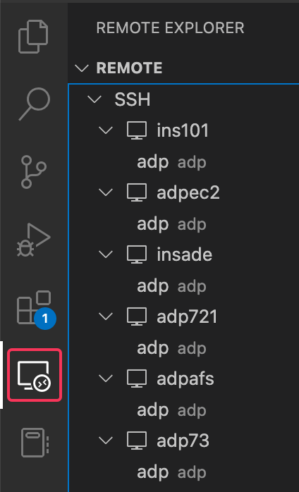
When you connect via the green >< selection in the status bar, you are prompted for the remote directory to open. If this is the first connection, VS Code will install its server side components before prompting. The remote explorer remembers which folder was the base folder opened, but also any editor windows you had open! Also, the green status bar item will show the ssh host value for the remote server.
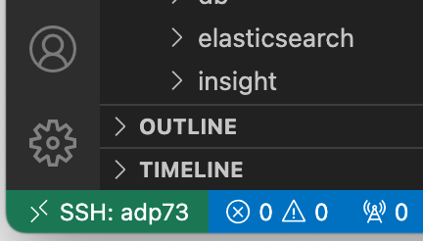

Now you can see and use the VS Code editor environment to access, edit, etc. the remote files.

If you open a terminal window in VS Code from the Terminal menu or by pressing Ctrl-`, you have a shell on the remote host. Here you can enter your normal ./adp.py commands as if you'd ssh'd to the server from your workstation.

On the Mac, you can drag items from Finder (it should work from Window Explorer also) into the folder structure in VS Code to upload them. You can't move them into one of the containers this way, but it gets them to the remote server. It doesn't look like you can drag files from the remote VS Code directories back to Finder. However, you can right click and select download.
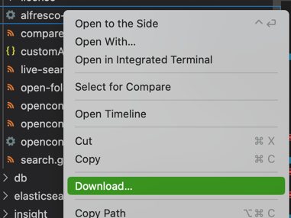

Pro Tip
The adp/data directory is available as /data from most if not all the containers. You can use the import or export folder under data to access files between the host server and the container. Permissions may not always be conducive to simple clean up. From the host EC2 server, the ec2-user has the ability to use the sudo command (allow to run the single command with elevated privileges). For example,
sudo chmod ugo+rw <filenames>
adds read/write for all users to the affected files.

